GEOLOGY

The Structure of the Earth

a) Inside the Earth
Scientists think that the Earth is composed of layers.

The outermost layer is like a thin skin and it is called the crust. The crust is solid and it is composed of rocks and minerals.

The crust is not an even layer; it is thickest where there are mountains ranges (and in general under the continents) and thinnest beneath the deep oceans.

The average thickness of the crust is about 30 km; the distance to the centre of the Earth is about 6500 km. That is, the crust is very thin compared to the distance to the centre of the Earth.

The temperature in the crust ranges from about 20⁰C (at the surface) to about 500⁰C (at the bottom of the crust). That is, the deeper you go into the crust (and the Earth) the hotter is becomes.

Beneath the crust is a much thicker layer called the mantle.

The mantle is about 2900 km thick and the temperatures range from about 500⁰C to 2000⁰C.

These high temperatures are enough to melt rock, and so the mantle is made up of partially solid, partially liquid (molten) rock. Sometimes molten rock spills out onto the crust as lava.

At the centre is the core which contains two main layers.

The outer core is believe to be made of molten iron and nickel. It has a thickness of about 2270 km and a temperature of about 3000⁰C.

The inner core is thought to be made of solid iron and nickel. It has a radius of about 1300 km and a temperature of about 4000ºC.

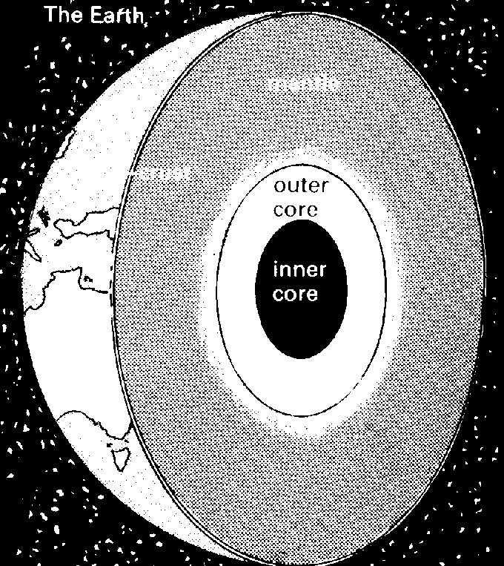

b) Plate tectonics

The theory of plate tectonics proposes that the outermost part of the earth, the crust, is divided into a number of rigid plates which move in relation to each other. There are six or seven major plates and a number of smaller ones. Both continents and ocean floors form the upper part of these plates. The Australian continent is on the Indian-Australian plate.

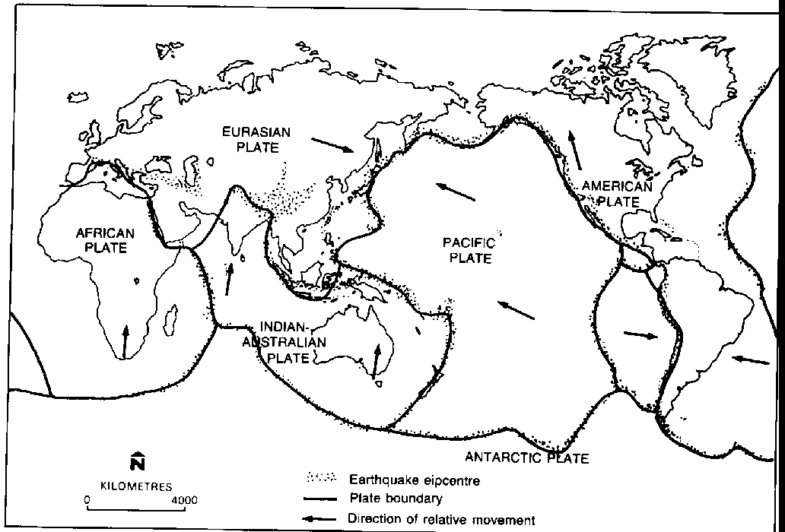

The tectonic plates are thought to be floating on the upper potion of the mantle and their movement is thought to be due to convection currents (movement of the hot mantle material) caused by the tremendous heat within the earth. The boundaries of these plates were determined by mapping the positions of earthquake epicentres because earthquakes tend to occur where plates meet or move apart.

Since the plates are moving with respect to each other, the edges or margins of the plates will be geologically unstable:

i) where two plates are forced together i.e. they are colliding, one plate is often forced under the other. The plate that is forced underneath moves back into the mantle. Collision zones of plates, called subduction zones, are often associated with earthquakes, volcanoes, ocean trenches and fold mountains.
This type of plate movement i.e. plate collision, is thought to have caused the formation of the Himalayas, in Asia, and the Andes mountains in South America. The ring of volcanoes around the Pacific ocean also is thought to be due to the Pacific plate is being pushed under other plates.
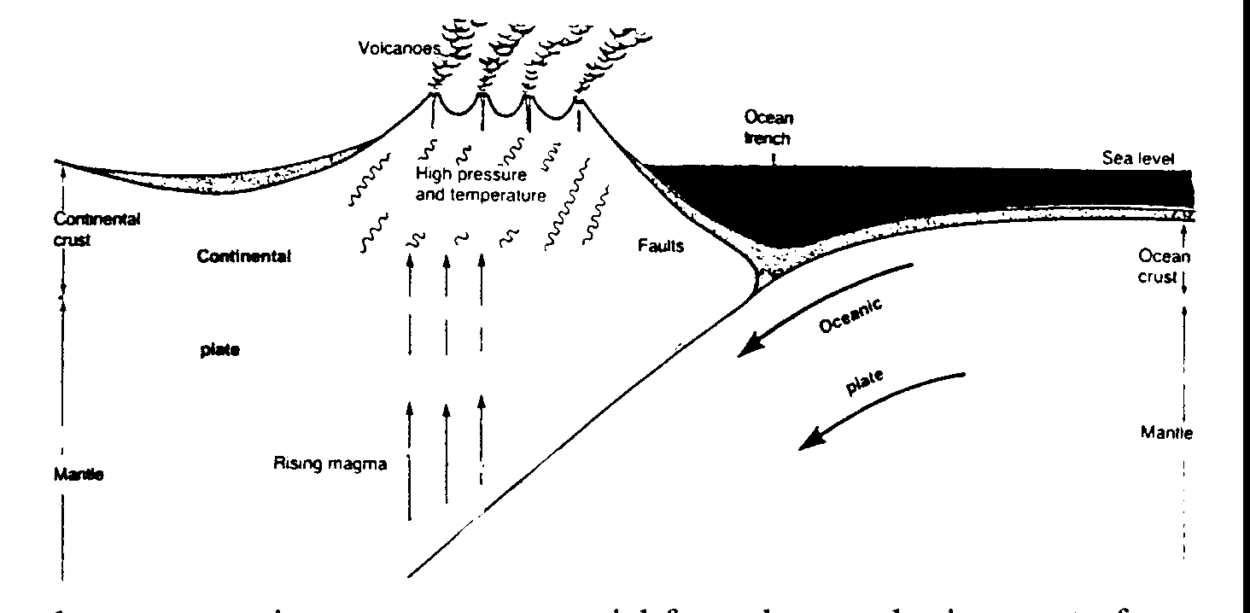

ii) where plates are moving apart, new material from the mantle rises up to form new crust.
Mid-ocean ridges (mountains), volcanoes and earthquakes are often associated with these areas.
Two plates moving apart are thought to have caused the formation of the mid-Atlantic ridge, a
mountain range under the Atlantic ocean.
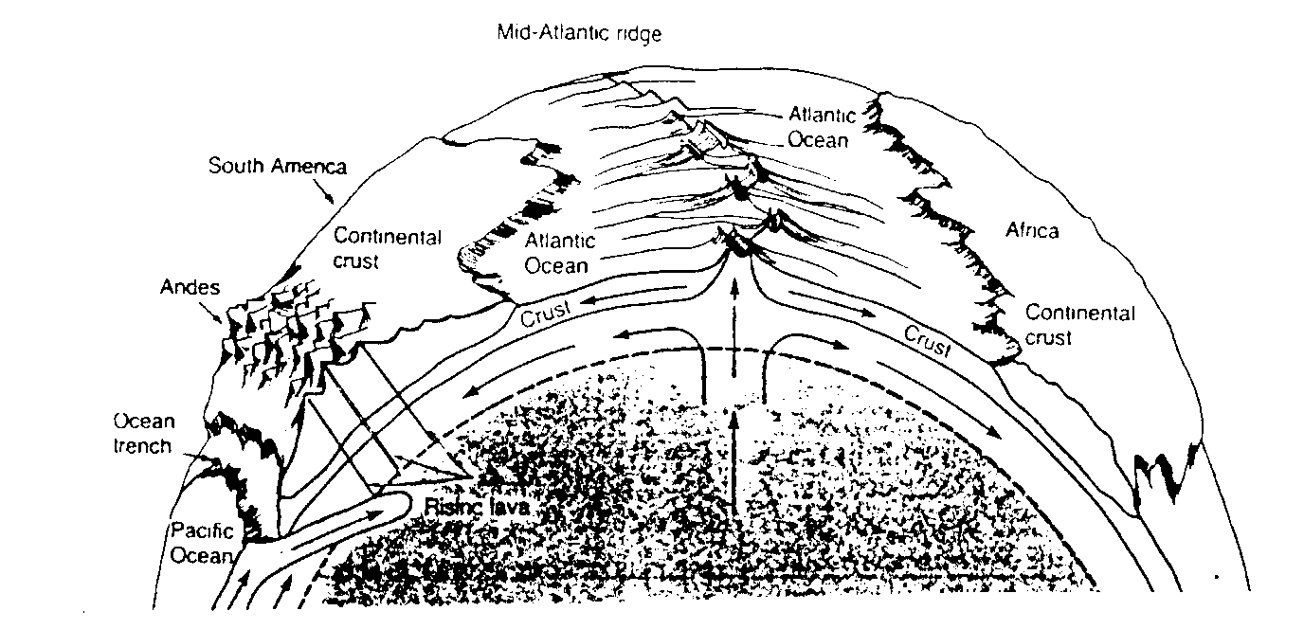

iii) where plates move past one another, faults, or breaks, occur in the rocks. This is called lateral movement of plates. Active volcanoes are absent in these areas, but severe earthquakes can occur as the two plates move in "jerky" movements past one another.
This type of plate movement occurs along the western coast of North America, and it forms the
San Andreas fault.

As the plates move over the surface of the Earth, they carry the continents with them. It is thought
that the continents were originally one land mass and over the billions of years they have slowly moved apart (and they are still moving!).
The continents
225 million
years ago.
65 million years ago
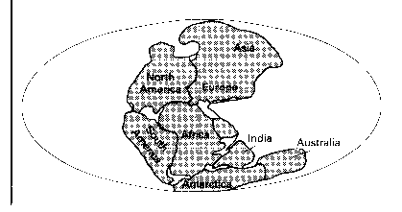  Present day | 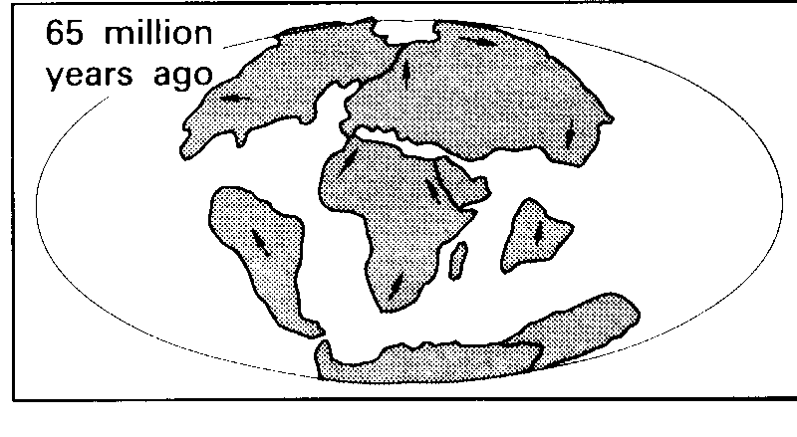 | 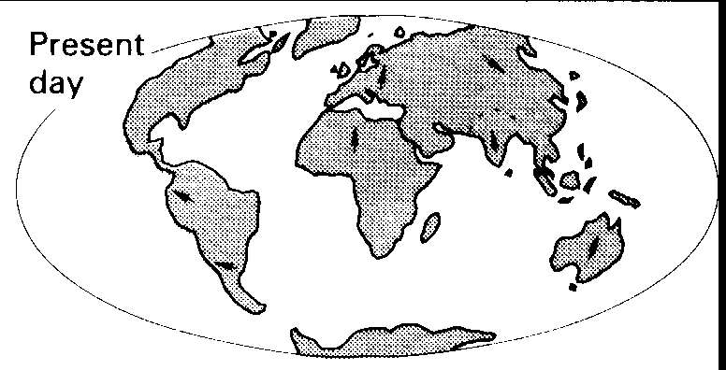

c) Volcanoes

Sometimes, due to pressure in the mantle layer, magma (molten rock) is forced through a weak part in the Earth's crust. When this happens, a volcano forms. The fluid magma which flows out of a volcano, over the surface, is called lava. "New" rock is formed when molten lava cools. Smoke, steam, ash and other gases also pour out of a volcano during an eruption.

d) Mountain building

The layers of rocks that make up the Earth’s crust are being continually pushed, twisted, split and folded by Earth movements. Mountains are often formed because of these tremendous forces exerted within and on the Earth’s crust:
Folding of the crust can occur because of these forces. For example when two plates collide, fold mountains often form at the edge (or edges) of the plate. Most of the Earth’s mountain ranges have been formed this way.
Another way in which rock layers may react to huge forces is by splitting or faulting. When a crack or a break forms in a layer of rocks, the rock on one side of the crack can move up, down or sideways, relative to the rock on the other side of the crack. This may result in one part of the Earth’s crust being higher compared to an adjacent part.
Folding of layers of rock
Faulting of rock layers
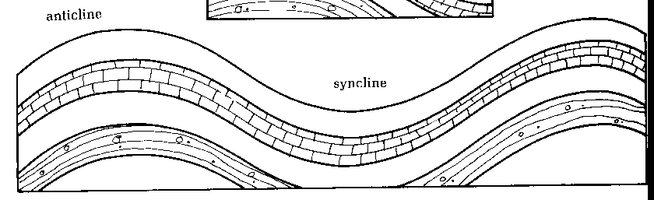 | 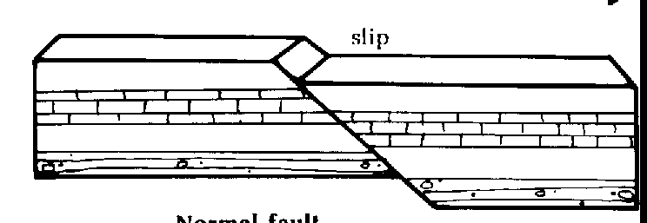

Igneous Rocks

Rocks which at one time were molten i.e. magma, are called igneous rocks. These rocks are composed of interlocking crystals. (Crystals are solids with a definite shape and straight, sharp edges)

Igneous rocks can form from magma in two ways:

i) when magma reaches the earth's surface, it becomes lava. Lava cools relatively quickly and produces igneous rock made up of small crystals. An example of rock formed this way is basalt.
Basalt is normally a dark-coloured, hard rock.
ii) at times, magma cools and solidifies below the Earth's surface . When this occurs, cooling is very slow, and the rock formed is composed of large crystals. An example of rock formed this way is granite.
The magma which forms granite is too thick to be forced through weaknesses in the earth's crust, and it forms great domes underneath the surface. In time, the surrounding softer rocks are eroded, leaving the rounded domes of granite.
Granite is a multicoloured rock composed of quite large interlocking crystals.

Sedimentary Rocks

a) Weathering

Weathering is the process by which rocks are broken down into smaller pieces or changed to other substances when exposed to the atmosphere. This process is caused by contact of the exposed outermost parts of the rock with water, air and living things.

Two types of weathering occur:

i) Physical Weathering
- this results in rock being broken down into smaller pieces (the composition of the rock is not changed).
- physical weathering can be due to - temperature changes
- action of frost or ice
- abrasion by moving particles
- action of plants and animals
ii) Chemical Weathering
- this results in the rocks being changed into different substances.
- chemical weathering occurs when air and water come in contact with rock and a chemical reaction with the rock occurs
- some of the chemicals in the environment that cause chemical weathering are:
- carbonic acid, which is formed when carbon dioxide dissolves in water
- humic acid, which is a weak acid formed from decaying plants in the soil.
- oxygen and water

b) Erosion

Erosion is the process of removal of the weathered rock particles from the bedrock locality i.e. from the place where they were formed from the parent rock.

The main agents of erosion are:

i) water - moving water in the rivers, steams and in the ocean can transport rock particles from one place to another. The faster the movement of water, the larger the rock particles that can be moved.
- water running over and through soil and rocks also causes erosion of small rock particles and soluble
substances.
ii) ice - a glacier is a very large river of ice and as it flows downhill it carves out a large
valley by breaking off pieces of rock and carry them with it.
iii) wind - the ability of wind to carry particles is less than that of water. However, wind can move much faster that water , and so can still carry quite large sand/rock particles.

c) The formation of sedimentary rocks.

The weathered materials carried by water, ice or wind in the process of erosion, will finally be "dropped" or deposited somewhere. This process is called deposition or sedimentation.
The weathered material which is deposited during erosion is called sediment. Over time, different layers of sediment often form on top of one another.
Layers of sediment can also be formed when a mixture of rocks and sand are deposited at the one time from the flowing water. The heaviest material will settle quickest i.e. it will form the bottom layer, then the next heaviest will settle etc. Thus layers, with the heaviest material at the bottom to the lightest as the top layer, will be formed.

As sediment builds up, layer upon layer, it can be very slowly converted into rock, called a sedimentary rock.
The process of forming many sedimentary rocks involves first compaction (pushing the particles in the sediment close together), and then secondly, the cementing of the particles together by chemicals.

That is, in a sediment, the particles are just mixed together, but in a sedimentary rock, the particles are "cemented" together to form a solid piece of material.

Some sedimentary rocks are formed from solids which have precipitated out of solution (salt), and other from remains of plants and animals that have been cemented together (limestone).

Sometimes plants or animals e.g. shells, form part of a sediment. These dead plants and animals then become part of the sedimentary rock which forms. The remains or imprints of these plants and animals in the rock are referred to as fossils.

d) Characteristics of sedimentary rocks

i) Most sedimentary rocks have a layered structure. In a series of layered rock, normally the oldest (first deposited) rock is at the bottom, and the youngest (last to be deposited) is at the top.
ii) Some sedimentary rocks show the remains of animals and plants trapped in the rock i.e. they contain fossils.
iii) Many sedimentary rocks contain grains cemented together.
iv) Sedimentary rocks are often much softer than igneous or metamorphic rocks.

e) Some common sedimentary rocks

Conglomerate - composed of large rounded pebbles (> 2mm in diameter) cemented together.
Sandstone - composed of medium sized sand grains (< 2mm and visible to naked eye)
Mudstone - composed of a mixture of silt and clay sized particles , cemented together
Limestone - composed of calcium carbonate and is normally pale in colour
- can be made of shell, coral or bone fragments cemented together
- can be formed by the precipitation of calcium carbonate from aqueous solution
Coal - black or brown solid composed mainly of carbon
- formed from plant material that has been compressed under layers of sediment.

Metamorphic Rocks

When solid rock is subjected to heat and pressure in the earth's crust, it can change into a different rock. This new rock is called a metamorphic rock.

Metamorphic rocks are often formed from rock which is formed or buried deep in the Earth's crust where there would be high temperatures and pressures. They are also formed in the crust in volcanic areas because the magma heats the surrounding rocks to sufficiently high temperatures to change them into metamorphic rocks.

Metamorphic rocks are normally much harder than sedimentary rocks and they sometimes have visible grains.

Examples of metamorphic rocks include:
- marble - often white, has visible grains and is formed from limestone.
- quartzite - very hard, has visible grains and is formed from sandstone.
- gneiss - has visible grains and normally contains dark bands. It is formed from shale, which must first be changed into other metamorphic rocks before gneiss is finally formed.

Marble and quartzite are normally formed in areas where the heat is supplied by volcanoes. However, gneiss is formed deep in the crust where high pressure and temperature conditions exist.

The Rock Cycle
The rock cycle shows the relationship (or changes) between igneous, sedimentary and metamorphic rocks:

IGNEOUS ROCKS

melting to form magma
melting to form magma
weathering, erosion,
deposition & cementation
heat & pressure

weathering, erosion,
deposition & cementation

METAMORPHIC ROCKS
SEDIMENTARY ROCKS
heat & pressure

Fossils

a) A fossil is any remains, impression or trace of an animal or plant that has been preserved naturally in the Earth's crust, normally in sediments.

b) Formation of fossils
Usually when an animal or plant dies, it rapidly decomposes in the presence of air. If however the dead organism is buried, or covered quickly with sediment, the rate of decomposition is greatly reduced. The organism, particularly the hard parts, can therefore become part of the rock that slowly forms from the sediment.

c) Types of fossils include
- original remains - rarely are soft parts of an organism preserved as a fossil, except perhaps in ice. However, original
hard parts, e.g. bones or shells, are sometimes found
- petrified wood and bones - remains of wood and bone that have been changed to stone are said to have been
petrified. Each cell in the organism is replaced by stone.
- impressions - sometimes, after burial, the hard part of an organism may completely dissolve, but it will leave an
impression on the surrounding rock.
- traces - e.g. the preserved footprints of animals walking over mud.

Fossils (or the organisms from which the fossils were derived) are classified in the same way as other animals and plants i.e. in kingdoms, phylum, class etc. From fossils, many animals and plants which no longer exist, have been identified. Many of the fossils have also been dated, so we have an idea of the time during which particular organisms lived on Earth.

d) Geological uses of fossils
Fossils are very important as a research tool. They enable geologists to correlate(match) and date layers of sedimentary
rock, and they provide evidence about past forms of life and past environments and climate.
i) Correlation of sedimentary layers.
Layers of rock which contain similar fossils are thought to have been formed at similar times. Consequently, if the age of one layer is known, and it matches (the fossils in it are the same) or correlates with another layer from another
location, then we can probably conclude that both layers are of approximately the same age.
ii) Index fossils
Some fossils are used by geologists as index fossils i.e. the fossil's age is determined and then the fossil and the rock layers in which it was found are matched to other layers of rock and so are used to determine the age of the other layers. To be chosen as an index fossil, the fossil must be of an animal and plant which lived only a short time in geological
history, yet achieved widespread distribution i.e. so that the fossil will be present in many different locations.
The age of these index fossils can be determined by radioactive dating methods.

